Fire Apparatus Photography by FireNews.net
Web page archive created April 2021 by Mike Legeros
Content originally created March 2005 by FireNews.net, copied via http://web.archive.org/web/20080219172029/http://www.firenews.net/contents/app_photo_05.htm

FireNews.net Special Series
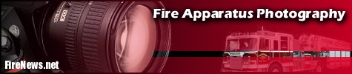
FireNews.net is pleased to present our newest feature:
"Fire Apparatus Photography."
In this series, we will help the aspiring photographer achieve better photos of fire trucks. It takes just a few minutes of planning and having the apparatus moved to the right spot to capture great shots.
We invite your submissions for new deliveries and for you to participate in our new upcoming series: Firehouse Spotlight.
Truck Placement
A few simple steps in regards to lighting and apparatus placement will go a long ways towards framing the perfect shot.
Do's and Don'ts
An insider's look at a few typical goofs. We've all made them; here's your chance to avoid them.
Technical Stuff
Nothing too technical here, just a few basics you want to keep in mind. Guides for digital and film cameras.
Examples
A gallery of examples by prolific apparatus photographer Lee Wilson.
Photographer's Checklist
A simple guide to help you remember the important items.

FireNews.net Special Series
Truck Placement
Use these diagrams as a guide. Make sure you have the right camera angle and that your lighting is optimized. Most errors in apparatus photography relate to how the truck is actually positioned. Fortunately, the trucks are equipped with big tires and a steering wheel to fix these problems!
If the truck is not in the correct spot, ask to have it moved.
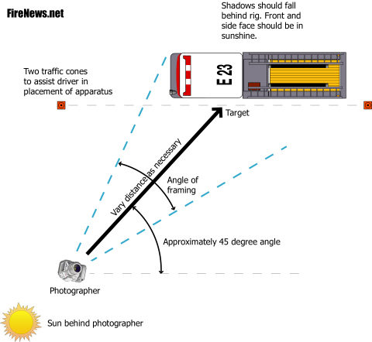
The above diagram shows how to check your sun angles and confirm your "target." Before asking an apparatus operator to move a vehicle to a certain spot, figure out your angles ahead of time.
Buy two inexpensive traffic cones and pre-deploy them so that the driver will know what angle you are trying to achieve with the truck. It's often hard to communicate this simple information when the engine is running. Most drivers will understand the simple request to "line it up with the cones."
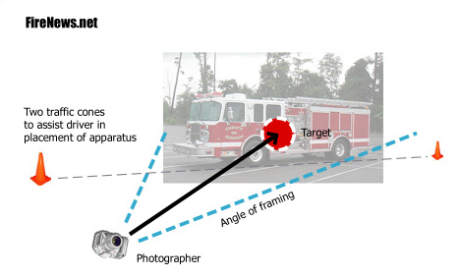
The above diagram depicts what you should be looking at and evaluating before you take the shot. You should be looking at some of the front and most of the side of the unit. This is commonly referred to as a 3/4 shot.
The truck should fill 90% of the frame from left to right. Please leave us some room to crop the picture. The target should be in the middle of the frame. Make sure the shadows fall behind the apparatus, and that the front and side are well lit.
Once the truck is parked, make any adjustments by using your feet! Move closer or further away from the unit.
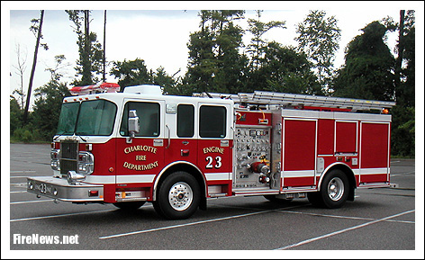
The final picture. This truck was actually photographed in a very light rain.
- Photo: Jeff Harkey, CFP-700
- FireNews.net Staff
Copyright © 2003-2006 - CAROLINAS FIRE PAGE - FireNews.net

FireNews.net Special Series
Do's and Don'ts
Here's a critical look at some common mistakes. These are usually corrected by different placement of the rig or the camera.
Apparatus not fully in frame. Only use apron shots if the lighting is correct and you have enough space.
Camera angle too sharp.
Equipment raised/extended/activated. Ladders and light towers should not be raised. Lights should be off.
Open compartments. All compartments should be closed. Shoot on flat areas, avoid slopes.
Heavy shadows from tree. Target should be closer to pump panel, and photographer should be further back.
Lack of any camera angle. Front of rig not shown.
Do not try to take apparatus shots inside the station.
Don't submit shots from parades.
Driver is in apparatus. Closed bay door would yield a better shot. Avoid a background with colors that blend with the apparatus. Contrast is best.
Pump panel side in dark shadows.
While this is a dramatic shot, the camera position is too low for our purposes.
Working fires are not the best place for posed apparatus shots.
Watch those backgrounds. Light poles, signage and power lines can wreck your composition. Watch those foregrounds too. In a parking lot, avoid the painted lines if you can. A field or concrete pad is preferred.

- Submitted by Mike Legeros. Various photographers concealed to prevent embarrassment.
- FireNews.net Staff
Copyright © 20053-2006- CAROLINAS FIRE PAGE - FireNews.net

FireNews.net Special Series
Technical Stuff
Fortunately, with today's digital media, taking excellent apparatus photographs are not difficult nor expensive.
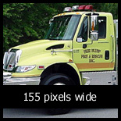

Here's the good news: you don't need a fancy camera. Almost any digital camera will work just fine. Leave the 16 mega-pixel cameras to the pros. All images that you see on the web are presented at just 72 dpi (dots-per-inch). This resolution is easily achieved with the most basic camera.
Most of the apparatus shots run on FireNews are presented at 450 pixels wide. Occasionally, if we have really good shot, we'll run an enlargement around 700 pixels wide. Click here for a sample.
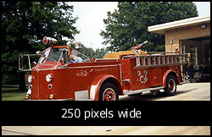

In addition to the typical "3/4" shot that we require, we also like to run other views of the rigs, so feel free to send those too. Click here for an example.
If your camera has a manual setting, select one notch above the "web" setting.
We do not accept images from a camera phone.
Do not use a flash of any kind.
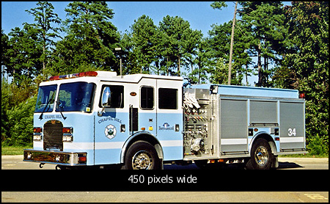
If you are still loyal to film cameras, please scan your prints at at least 150 dpi, and submit as a jpg or tiff. Do not convert any images to gifs.
When using a SLR camera, the best lense to use is a 50mm. This approximates what the human eye normally sees without distortion. Any wide angle lense (28mm for example) will lead to a "fish-eye" effect. Zoom lenses tend to flatten out the image perspective.
- Middle and bottom photos: Lee Wilson, CFP-702
- FireNews.net Staff
Copyright © 2005 - CAROLINAS FIRE PAGE - FireNews.net

FireNews.net Special Series
Examples
FireNews photographer Lee Wilson presents a select group of posed apparatus shots. Note the foreground and background of each composition. Shadows fall behind each unit. The images below represent a mix of digital photography and scanned prints.
Images presented here are 450 pixels wide, the enlargements are 700 wide. For an enlarged version of each photograph, click the image.
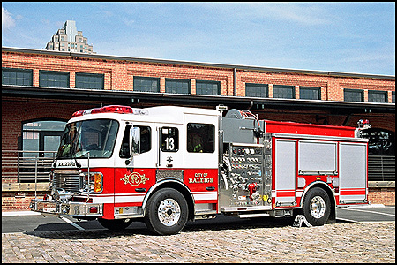
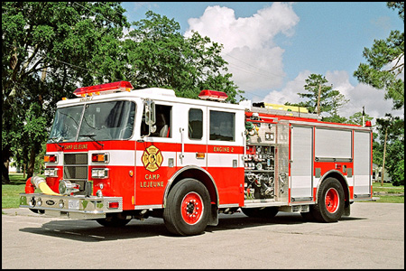
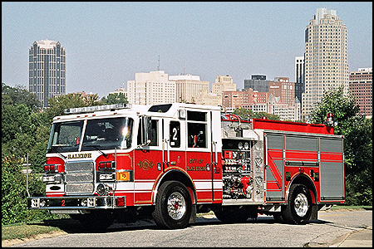
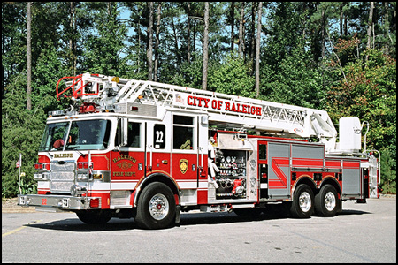
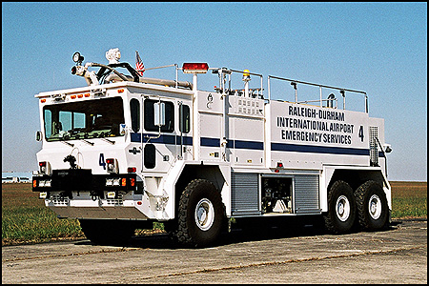
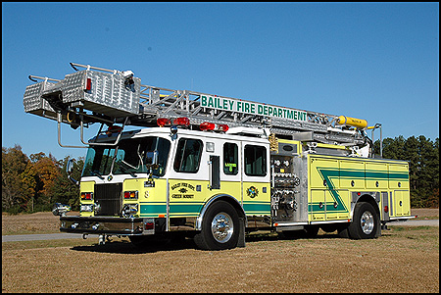
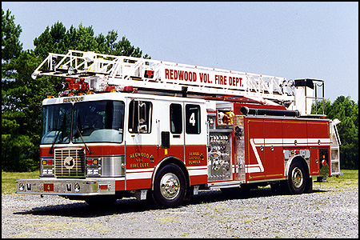
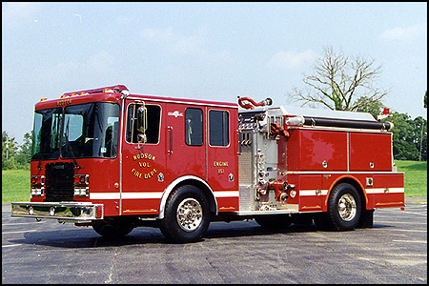
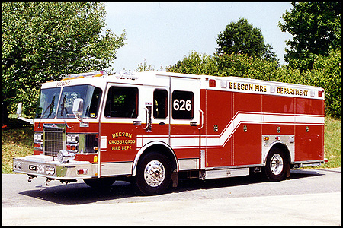
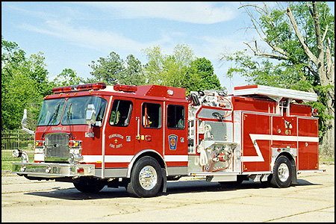
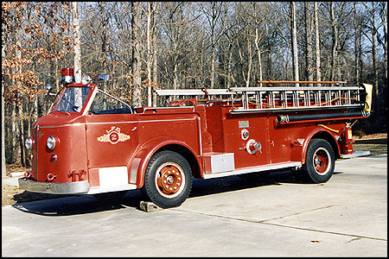
- Send Lee an email about his pictures.
- FireNews.net Staff
Copyright © 2003-2006 - CAROLINAS FIRE PAGE - FireNews.net

FireNews.net Special Series
Checklist
Print off this simple checklist before you hit the fire stations. Keep it with you until you become proficient at taking apparatus shots. Soon it will become second nature.

Camera, with digital media or film (ASA 100 recommended).
Spare batteries, charger.
Notepad and pen for getting truck details. Take note of any unusual aspects.
Two traffic cones to assist the Apparatus Operator with truck placement.
A bottle of Armor-All or similar for tire shine. Be sure to get the OK first.
Disposable rags for the Armor-All.
Be aware of the time of day. Avoid high noon sun. Spring and fall are best.
Scout out the background for obstructions, visual clutter.
No people or other vehicles in the scene.
All lights off, including warning and running lights.
Windows rolled up, compartment doors closed.
Clear the dash of distractions: map books, helmets, etc.
Close station overhead door if taking a shot on the apron of the station.
Check your angle for proper lighting.
If the driver uses a wheel chock, move it to the side opposite of your shot.
Advanced users: wet the pavement for a sexy shot!
Fill the frame with 90% of the rig.
Watch for a sneaky shadow from trees, flagpole, etc.
Get the typical 3/4 shot of the driver's side.
Take several shots, submit the best ones later.
Thank the firefighters for their time. Ask if they would like copies. Make sure to follow-up on any promises.
Apparatus Details:
Fire Department
Unit Numer
Year Manufactured
Manufacturer
Pump GPM
Tank Capacity
Aerial Size

- FireNews.net Staff
Copyright © 2003-2006 - CAROLINAS FIRE PAGE - FireNews.net

